Copulas: GBPUSD and USDCAD
Method 18 / daily log returns / empirical ranks / Gaussian + Clayton / Alpari D1 full available history

Study setup
Logical pair: GBPUSD , USDCAD
Broker symbols: GBPUSD_i , USDCAD_i
Snapshot: 2026-11-03_majors_alpari_D1
Timeframe: D1
Matched return window: 1999-01-05 to 2026-11-02 (UTC bar dates)
Matched return count n: 7205
Dropped unfinished last bar dated 2026-11-03 UTC after a tick-volume check against the prior complete day.
Margins: empirical ranks / (n+1)
Families: Gaussian (rho) and Clayton (theta), fixed before ranking
Complete matched rows (Excel): GBPUSD-USDCAD_Copula_D1.xlsx
Complete matched rows (HTML table): GBPUSD-USDCAD_Copula_D1_data.html

Method carried forward
Copulas separate marginal return shapes from dependence on the unit square. Matched daily log returns of close, ln(close_t / close_t-1), are mapped to pseudo-observations u_i = rank(x_i)/(n+1) and v_i = rank(y_i)/(n+1). A Gaussian copula parameter rho is the Pearson correlation of Phi^{-1}(u) and Phi^{-1}(v). A Clayton copula theta >= 0 is fit by maximum likelihood on (u,v) for lower-tail asymmetry. Quotes are not inverted. Kendall tau implied by each fit and Spearman of (u,v) are stored. Same-sample Pearson r on returns is a side check. This is not causation and not a trading signal.

Results
Gaussian rho: -0.439996
Gaussian Kendall tau: -0.290041
Clayton theta: 0.000000
Clayton Kendall tau: 0.000000
Spearman of (u,v): -0.404480
Pearson r on returns: -0.456462

Conclusion
Over 7205 matched daily rows for GBPUSD and USDCAD, Gaussian copula rho = -0.4400 (Kendall=-0.2900) and Clayton theta = 0.0000 (Kendall=0.0000). Spearman of (u,v) = -0.4045; Pearson r on returns = -0.4565. This is not causation and not a trading signal.

Charts
Daily closes

Daily log returns

Pseudo-observations (u,v)
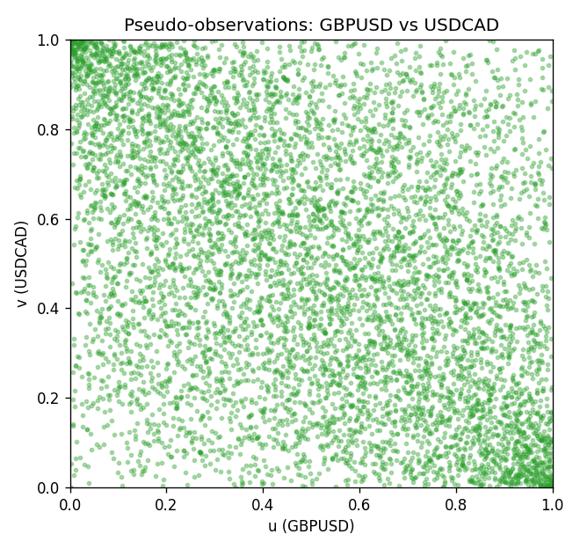

Data report
Every matched row is stored in the sibling Excel workbook named GBPUSD-USDCAD_Copula_D1.xlsx, including u and v. Embedding all rows as a Word table is impractical; this file holds column summaries and the first and last 15 matched rows.
Columns: time, GBPUSD_open, USDCAD_open, GBPUSD_high, USDCAD_high, GBPUSD_low, USDCAD_low, GBPUSD_close, USDCAD_close, GBPUSD_tick_volume, USDCAD_tick_volume, GBPUSD_spread, USDCAD_spread, GBPUSD_real_volume, USDCAD_real_volume, GBPUSD_log_return, USDCAD_log_return, u, v
Column summaries (matched calculation rows)
column | count | mean | std | min | 25% | 50% | 75% | max
GBPUSD_open | 7205 | 1.5161639 | 0.2182756 | 1.06854 | 1.32505 | 1.51142 | 1.63205 | 2.1066
USDCAD_open | 7205 | 1.2670469 | 0.16900802 | 0.9168 | 1.119 | 1.29857 | 1.3723 | 1.6183
GBPUSD_high | 7205 | 1.5224596 | 0.21884187 | 1.08366 | 1.32981 | 1.5182 | 1.6384 | 2.1161
USDCAD_high | 7205 | 1.2719479 | 0.16896591 | 0.9336 | 1.1234 | 1.30394 | 1.3769 | 1.619
GBPUSD_low | 7205 | 1.5098441 | 0.21750249 | 1.03518 | 1.31956 | 1.50336 | 1.62444 | 2.0983
USDCAD_low | 7205 | 1.2624879 | 0.16904619 | 0.9056 | 1.1144 | 1.29361 | 1.36793 | 1.6102
GBPUSD_close | 7205 | 1.5162333 | 0.21823062 | 1.06879 | 1.3252 | 1.5114 | 1.6322 | 2.1065
USDCAD_close | 7205 | 1.2670655 | 0.16898286 | 0.916 | 1.11851 | 1.29871 | 1.37253 | 1.6137
GBPUSD_tick_volume | 7205 | 94776.836 | 153518.92 | 62 | 9986 | 52867 | 91739 | 1273370
USDCAD_tick_volume | 7205 | 80835.261 | 147176.39 | 37 | 5509 | 40849 | 71515 | 1410818
GBPUSD_spread | 7205 | 26.978348 | 19.192834 | 0 | 11 | 20 | 50 | 50
USDCAD_spread | 7205 | 23.508952 | 18.282466 | 0 | 9 | 17 | 40 | 60
GBPUSD_real_volume | 7205 | 3.5541156e+09 | 8.441481e+10 | 0 | 0 | 0 | 0 | 2.4038164e+12
USDCAD_real_volume | 7205 | 1.8330194e+10 | 9.6578305e+10 | 0 | 0 | 0 | 0 | 2.5751613e+12
GBPUSD_log_return | 7205 | -2.188e-05 | 0.00563988 | -0.08388241 | -0.00312535 | 3.221e-05 | 0.0031749 | 0.03112653
USDCAD_log_return | 7205 | -1.219e-05 | 0.00514402 | -0.03859748 | -0.00283601 | 4.92e-05 | 0.00272763 | 0.03436319
u | 7205 | 0.5 | 0.2886551 | 0.00013877 | 0.25006939 | 0.5 | 0.74993061 | 0.99986123
v | 7205 | 0.5 | 0.2886551 | 0.00013877 | 0.25006939 | 0.5 | 0.74993061 | 0.99986123
First 15 matched rows (selected columns)
time | GBPUSD_log_return | USDCAD_log_return | u | v
1999-01-05 | -0.0028966287 | -0.010131666 | 0.26588954 | 0.026783236
1999-01-06 | -0.00060452184 | -0.0003306769 | 0.44185401 | 0.4641965
1999-01-07 | -0.002118709 | 0.0015202092 | 0.32070497 | 0.65154038
1999-01-08 | -0.0058954193 | -0.0020495197 | 0.11795726 | 0.30432973
1999-01-11 | -0.0056851331 | -0.0035137769 | 0.12489592 | 0.20788232
1999-01-12 | 0.0022657001 | 0.0066194721 | 0.68873161 | 0.92464613
1999-01-13 | 0.0091330396 | 0.0045420214 | 0.95475992 | 0.85525951
1999-01-14 | 0.0019376331 | 0.0069376546 | 0.66167083 | 0.93172356
1999-01-15 | -0.0017558204 | -0.0056905671 | 0.34818207 | 0.10754926
1999-01-18 | 0.0012112405 | 0.00098344542 | 0.60380239 | 0.59714127
1999-01-19 | 0.0018745281 | 0.002748513 | 0.65598113 | 0.75159589
1999-01-20 | -0.0049053846 | -0.0059646885 | 0.15625867 | 0.099084097
1999-01-21 | 0.0031518998 | -0.0042823796 | 0.74798779 | 0.16208715
1999-01-22 | 0.0024781662 | 0.0025057712 | 0.70399667 | 0.73369414
1999-01-25 | 0.0012066366 | 0.00085579808 | 0.60338607 | 0.58520677
Last 15 matched rows (selected columns)
time | GBPUSD_log_return | USDCAD_log_return | u | v
2026-10-13 | 0.0036434319 | -0.0046395653 | 0.77740772 | 0.14932001
2026-10-14 | -0.0049164679 | 0.0015184751 | 0.15570358 | 0.65140161
2026-10-15 | 0.0065976411 | -0.0036101503 | 0.90341382 | 0.20205384
2026-10-16 | 0.0037592051 | -0.0034322068 | 0.7842076 | 0.21343325
2026-10-19 | -0.0017500314 | -0.0018835331 | 0.34929226 | 0.31876214
2026-10-20 | 0.0055923442 | -0.0037066008 | 0.87052456 | 0.19511518
2026-10-21 | 0.0012476328 | -0.00084691787 | 0.60657785 | 0.41409936
2026-10-22 | 0.00022396082 | -0.0026307268 | 0.51831807 | 0.26533444
2026-10-23 | -0.0021146949 | 2.85545e-05 | 0.32126006 | 0.49888981
2026-10-26 | -0.0024340661 | 5.7106554e-05 | 0.29683597 | 0.50083264
2026-10-27 | -0.0023648393 | 0.0025379458 | 0.30197058 | 0.7370247
2026-10-28 | 0.0015771808 | -0.0038379274 | 0.63349986 | 0.18553983
2026-10-29 | 0.0035881935 | -0.00011436495 | 0.77518734 | 0.48431862
2026-10-30 | 0.0013450605 | -0.0010298736 | 0.61448793 | 0.39578129
2026-11-02 | 0.0010971256 | 0.00061519094 | 0.59436581 | 0.56050513

